The Title of the Paper. Time New Roman Bold 16pt Font
K. I. Ivanov¹, V. F. Petrov²
¹Astrakhan State Technical University, Tatischeva str, 16, Astrakhan, Russia, ivanov@inbox.ru
²Volgograd State Technical University, Lenin avenue, 28, Volgograd, Russia, petrov@mail.ru
Abstract. The abstract should be from 100 to 250 words. The font must be Time New Roman Italic 11pt.
I. Introduction
The text should be written in Time New Roman 12pt font. The page size: top 2cm, bottom 3cm, right 1cm, left 3cm.
II. Formulas and Figures
The formulas must be formatted in the formula editors Microsoft Words
$$\vec{F}=\frac{d\vec{p}}{dt} (1)$$
The figure should be clear in any graphics editor.

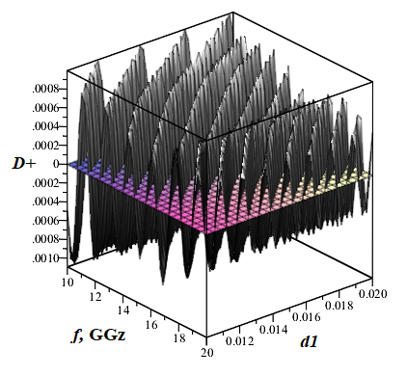
Fig.1. The example

Table 1. The example
q | i=1 | i=2 | i=3
1 | 23 | 34 | 23
2 | 54 | 45 | 12
3 | 78 | 65 | 14
4 | 23 | 91 | 16

III. Conclusion
The examples of the reference are given below.
References
[1] K. Vytovtov., L. Mospan, “Penetration effect in gyrotropic slab: theory and applications”, J. Opt. Soc. Am. A29(6), 2012, pp.877-882,
[2] K. Vytovtov, S Zouhdi., “Exotic reflection of plane waves by anisotropic structures” Proceedings of Metamaterials 2012: The Sixth International Congress on Advanced Electromagnetic Materials in Microwaves and Optics, 2012, pp. 648-650.
[3] R. A. Silin. Unusual laws of refraction and reflection. Moscow FAZIS, 1999, 80p.

